MFN Tariffs by Sector Across South Asia: Patterns, Priorities, and Policy Directions
Objective and Approach
This brief analyzes sector-level import tariff patterns across eight South Asian countries using the latest available MFN (Most Favored Nation) tariff data from the World Integrated Trade Solution (WITS). The objective is to identify policy signals in tariff structures, assess protectionist tendencies, and offer insights for trade harmonization and industrial upgrading.
Tariffs were mapped at the HS6 level and classified into 8 goods-producing sector groups using HS2 concordance. The analysis focuses on simple average ad valorem rates across sectors and countries.

Key Findings
- Cross-Country Tariff Variation
Country | Avg. MFN Tariff (%) | Notes
India | 24.6 | Highest overall; peaks in wood, textiles, fuel/chemicals
Afghanistan | 6.3 | Lowest; low across all sectors
Maldives | 8.5 | Low, especially in agriculture and machinery
Bangladesh, Nepal, Pakistan | 11–18 | Intermediate protection
India stands out with a consistent high-tariff profile, especially in capital- and labor-intensive sectors. Afghanistan and Maldives apply relatively liberal regimes, reflective of their limited domestic production bases or trade facilitation strategies.
Note: Pakistan's WITS data does not include tariff lines for vegetable oil chapters (HS 1507–1516), reducing textile sector line coverage relative to other countries. Averages are computed from available data.

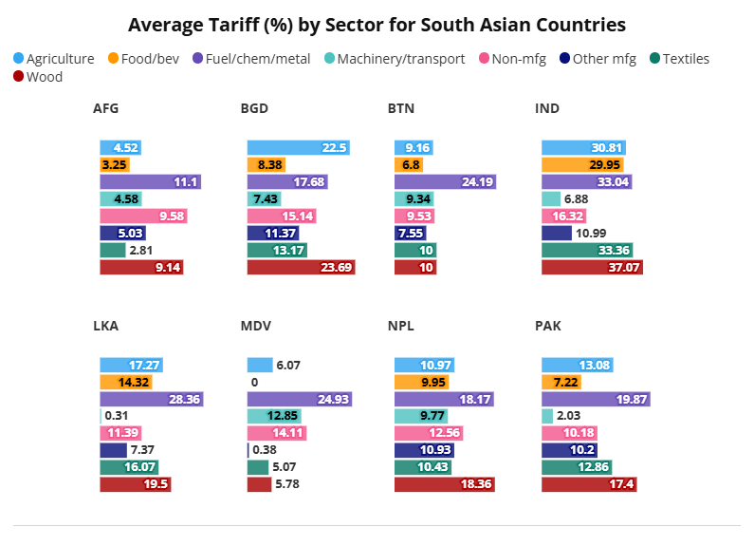
Source: WITS, latest available year.
2. Sectoral Hotspots and Outliers
Sector | Highest Tariff (Country) | Lowest Tariff (Country)
Agriculture | 30.8% (India) | 4.5% (Afghanistan)
Textiles | 33.4% (India) | 5.1% (Maldives)
Fuel/Chem/Metals | 33.0% (India) | 11.1% (Afghanistan)
Machinery/Transport | 28.4% (Sri Lanka) | 0.3% (Sri Lanka)*
*Sri Lanka’s machinery tariffs range widely, suggesting exemptions for select capital goods.

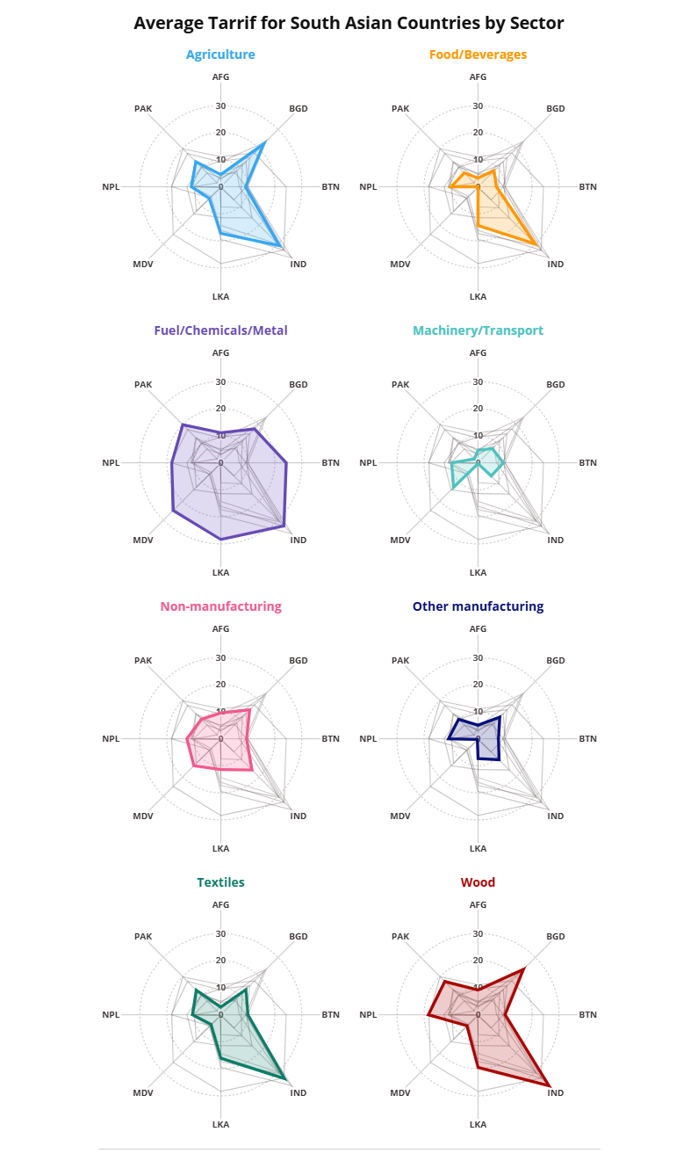

Source: WITS, latest available year.
Each radar chart shows average MFN tariffs by sector, allowing cross-country comparison along each axis. A country’s distance from the center indicates the relative protection level in that sector—the farther out, the higher the tariff.

Interpretation and Policy Insights
Protectionism vs. Liberalization
- India’s tariff regime reflects strategic import substitution, with particularly high rates on sectors like textiles (33.4%) and fuel/metals (33.0%).
- Afghanistan , contrasting with India and Pakistan’s protectionist stance.
Textile Paradox
India and Pakistan impose high textile tariffs despite being major global exporters, possibly to shield domestic producers from regional competition. Bangladesh’s more moderate stance may reflect a strategic balance between input costs and export competitiveness.
Capital Goods and Industrial Upgrading
Low machinery tariffs in Pakistan (2.0%) and partial exemptions in Sri Lanka (0.3–28.4%) may aim to support technological diffusion and modernization. In contrast, higher rates in India and Bhutan suggest room for revisiting capital goods policy to enable productivity gains.

Recommendations
1. SAFTA Tariff Harmonization
- Focus on intermediate goods (e.g., textiles, fuel/chemicals) where tariff misalignment raises input costs for regional value chains.
- Use SAARC platforms to establish tiered schedules for sensitive vs. strategic products.
2. Incentivize Capital Imports
- Countries with high machinery tariffs (e.g., India, Bhutan, Sri Lanka) should evaluate tiered or duty-free schemes for productivity-enhancing imports.
3. Align Tariffs with Export Strategy
- Rationalize high textile tariffs in India and Pakistan to reduce input cost pressures on exporters, especially in garments and apparel.
4. Reassess Agricultural Protection
- High tariffs (e.g., India: 30.8%) could have inflationary effects on food prices. Consider balancing producer support with consumer welfare.

Conclusion
The analysis reveals significant divergence in trade policy across South Asia. While some countries pursue protectionist strategies to shield domestic industries, others leverage liberal regimes to reduce input costs and encourage trade. Regional coordination, especially under SAFTA, can offer a path toward reduced trade costs, improved competitiveness, and more coherent industrial strategies.

